 | FARM MACHINERY TESTING CENTRE  Department of Farm Machinery and Power Engineering  College of Technology and Engineering  Maharana Pratap University of Agriculture and Technology  UDAIPUR – 313 001 (RAJASTHAN) | 
Phone : 0294-2470119, Email:fmtc.udz@gmail.com, Website: www.ctae.ac.in

SPECIFICATION SHEET OF SUBSOILER
1.0 | General
 | Name
 | Address of Manufacturer
 | Name & Address of Applicant
 | Selling price in India
2.0 | Technical Specifications
 | Type
 | Make
 | Serial Number
 | Model
 | Year of manufacture
 | No. of plough bottom(s)
 | Size of plough (mm)
 | Source of power
3.0 | Constructional Details
3.1 | Main frame:
a) | Constructional details
b) | Size (mm)
3.2 | Standard
a) | Numbers
b) | Material
c) | Type
d) | Dimensions (mm)
 | - Projected length
 | - Curved length
 | - Width
 | - Thickness
e) | No., size and spacing of hole on each standard for fixing share to it (mm)
f) | No. and size of bolts for tightening share to the standard (mm)
g) | Method of fixing
h) | Provision of height adjustments
3.3 | Share:
a) | Numbers
b) | Type
c) | Dimensions (mm)
d) | No., size and spacing of hole on each share for fixing it to standard (mm)
e) | Method of fixing share to the standard
3.4 | Types of hitch and its details:
a) | Type
b) | Constructional details

Sr. | Dimension | Description (Refer Fig.) | Dimension in mm
Upper Hitch attachments
1 | d₁ | Diameter of hitch pin hole
2 | b’₁ | Width between inner faces of yoke
3 | b’₂ | Width between outer faces of yoke
Lower hitch points
4 | D₂ | Dia of hitch pin
5 | b’₃ | Linch pin hole distance
6 | l | Lower hitch point span
Other dimensions
 | Diameter of linch pin hole
7 | d | For upper hitch pin
8 |  | For lower hitch pin
9 | h | Mast height
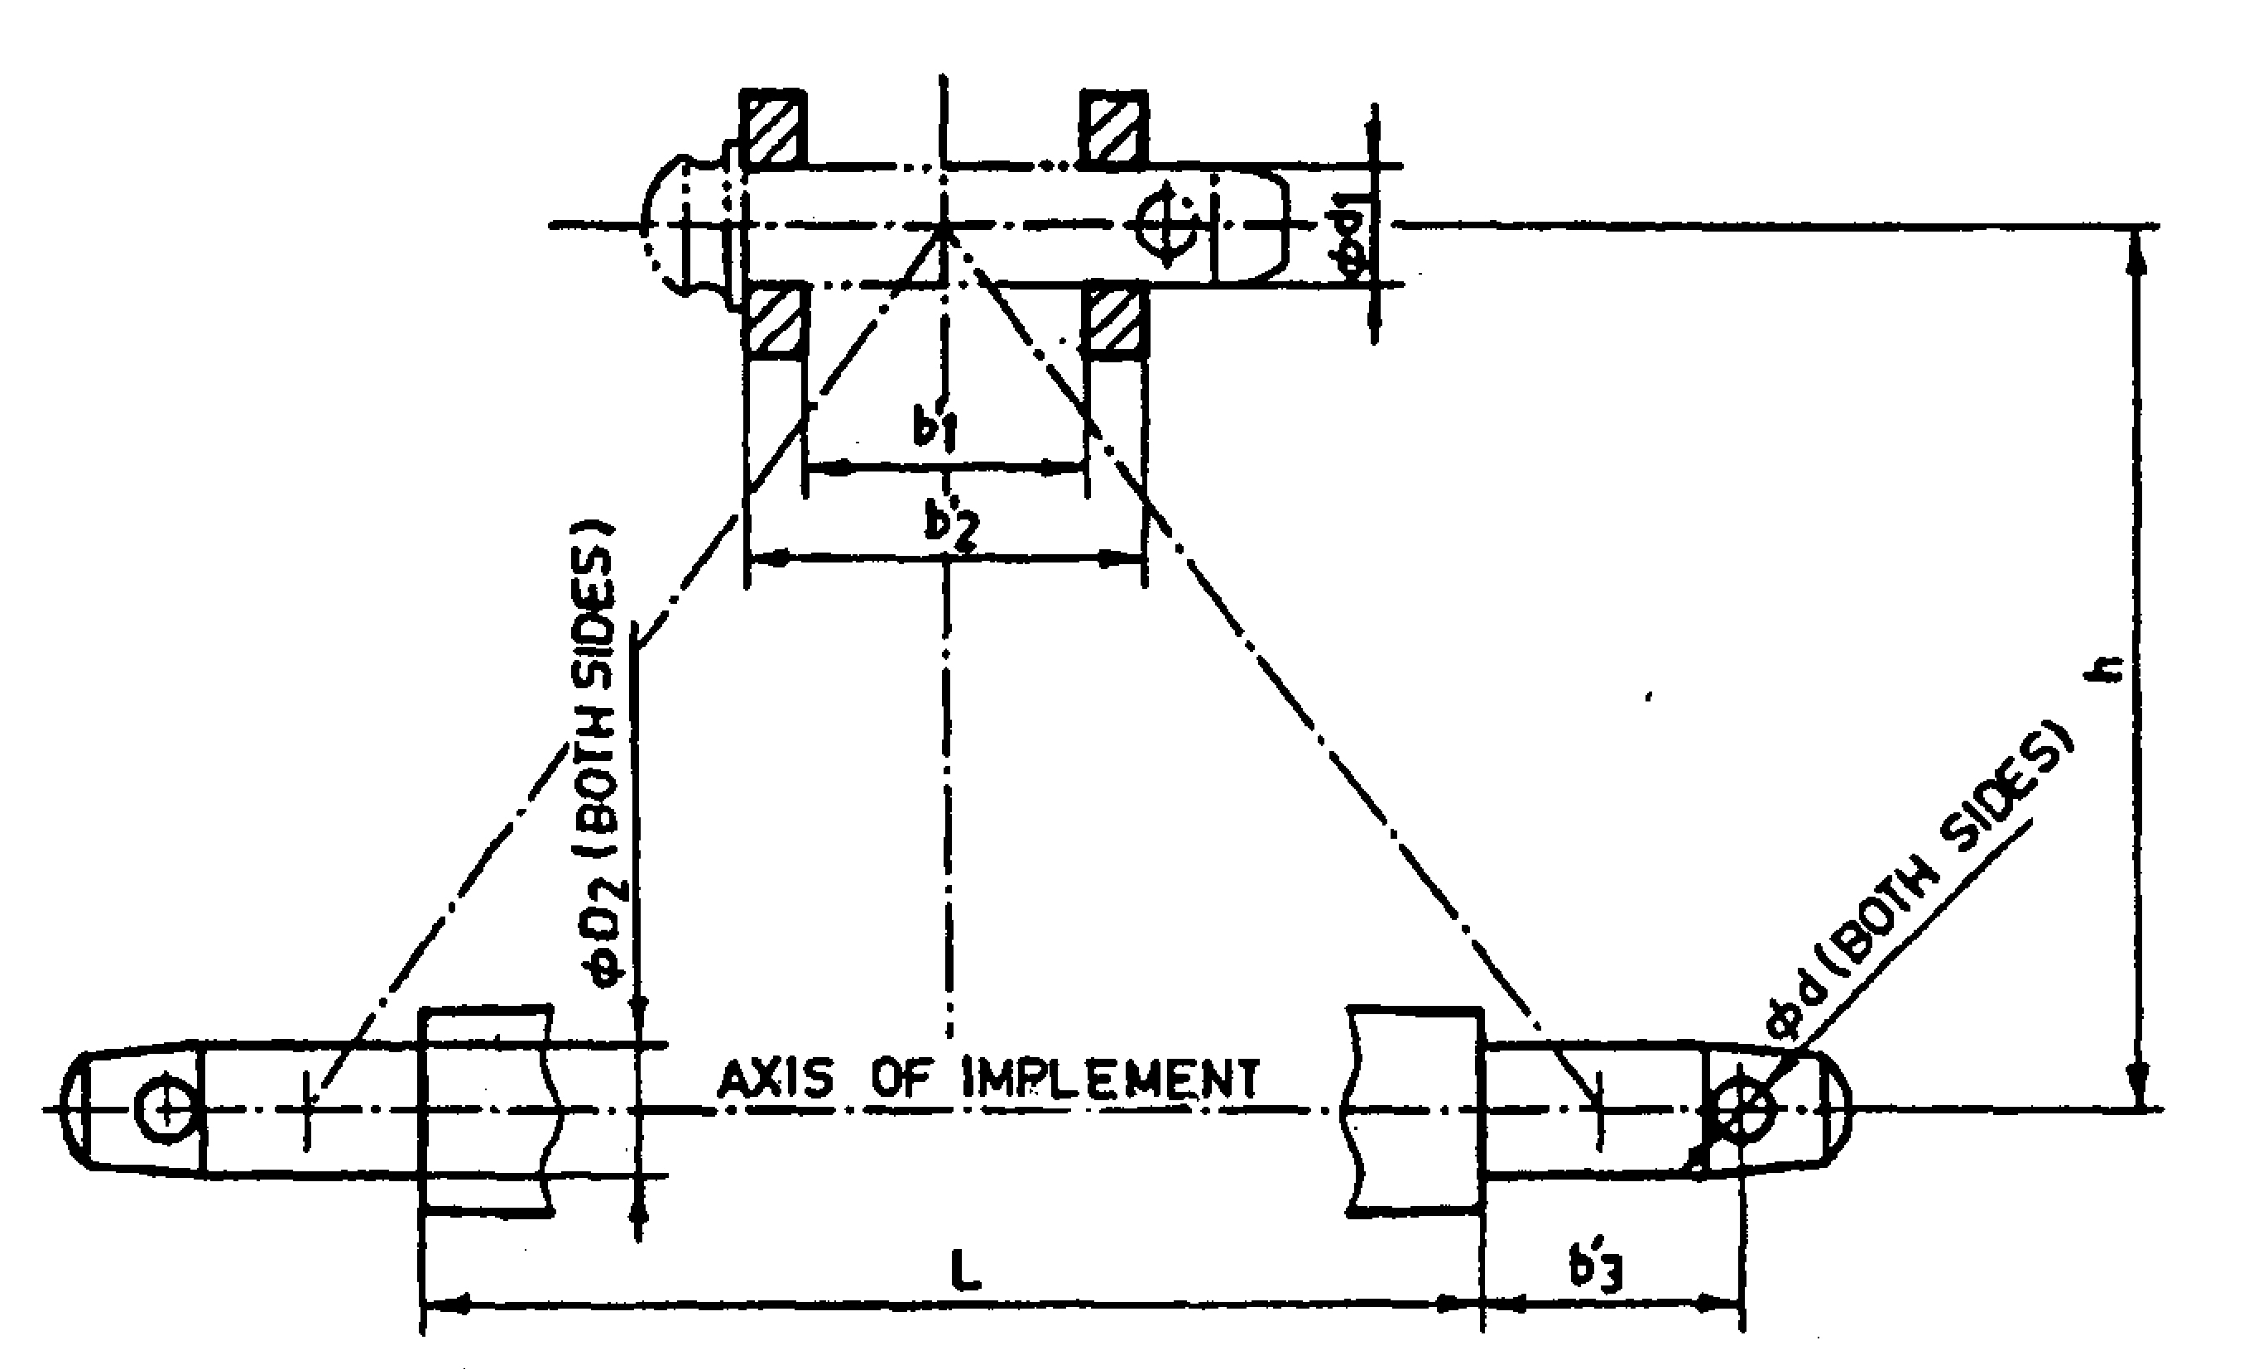
Fig. : Implement Hitch Attachment

6.0 | Overall dimensions (mm)
 | Length x Width x Height
7.0 | Mass of implement (kg)
8.0 | Colour
9.0 | Other specific details, if any

Place:
Date:
Signature : ________________________

Name : ________________________

Designation: ________________________

