 | FARM MACHINERY TESTING CENTRE  Department of Farm Machinery and Power Engineering  College of Technology and Engineering  Maharana Pratap University of Agriculture and Technology  UDAIPUR – 313 001 (RAJASTHAN) | 
Phone : 0294-2470119, Email:fmtc.udz@gmail.com, Website: www.ctae.ac.in

SPECIFICATION SHEET OF MULTICROP THRESHER (TRACTOR OPERATED)

1 | Name of Machine
2 | Name and address of Manufacturer
3 | Name and address of applicant
4 | Selling price in India

4 SPECIFICATIONS

4.1 | General:
 | a) |  | Name | :
 | b) |  | Type | :
 | c) |  | Make | :
 | d) |  | Serial Number | :
 | e) |  | Model | :
 | f) |  | Size of thresher (mm) | :
 | g) |  | Year of manufacture | :
4.2 | Design Suitability:
 | a) |  | Name of crop (as per applicant) | :
 | b) |  | Thresher evaluated for | :
4.3 | Power Unit:
 | a) | Type of prime-mover |  | :
 | b) | Recommended power requirement (hp) as per applicant |  | :
4.4 | Construction Details:
4.4.1 | Frame: |  |  | :
 | a) | Dimensions (mm) |  | :

4.4.2 | Crop feeding system:
 | a) | Method of feeding | :
 | b) | Nos. of feeding system | :
 | c) | Type of feeding | :
 | d) | Constructional details | :
 | e) | Size of feeding chute opening (mm) | :
 | f) | Height of feeding chute from platform (mm) | :
 | g) | Height of feeding chute from GL (mm) | :
 | h) | Specifications of feeding chute | :

Shape: The shape of chute shall be as shown in Fig.
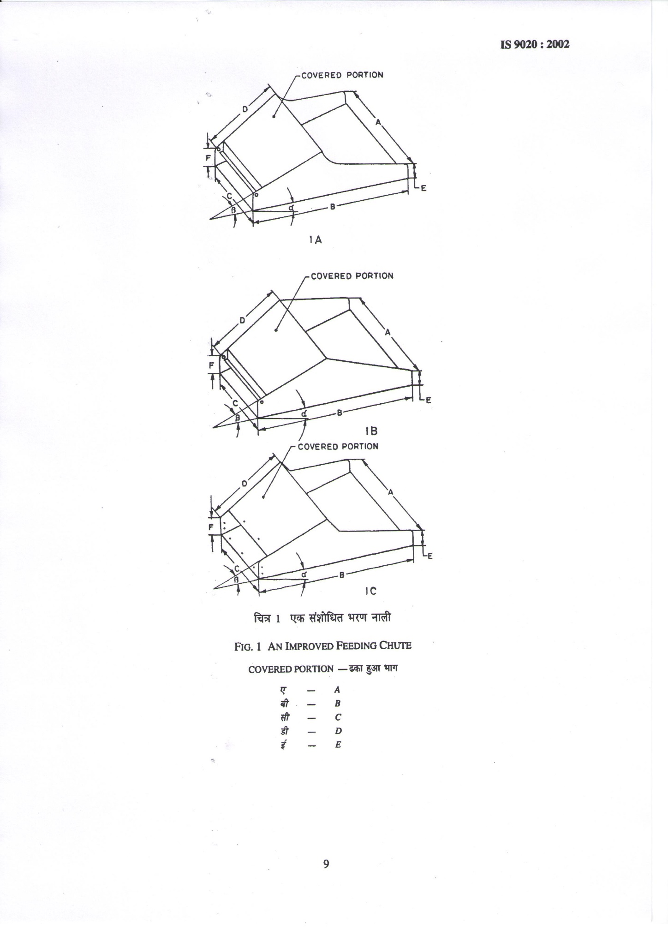
Fig. : Dimensions of Feeding Chute as per Indian Standard & as observed
-type
B
D
β
A
C
E
F
α

4.4.3 |  | Feeding platform:
 |  | a) |  | Constructional details |  |  | :
 |  | b) |  | Size of platform (mm) |  |  | :
 |  | c) |  | Height of platform from GL (mm) |  |  | :
4.4.4 |  | Threshing unit:
4.4.4.1 |  | Threshing cylinder:
 |  | a) |  | Type |  |  | :
 |  | b) |  | Size of cylinder (mm) |  |  | :
 |  | c) |  | Constructional details |  |  | :
 |  | d) |  | Main shaft:
 |  |  |  | -Material and size (mm) |  |  | : |  |  | MS rod, 2340x50.0 Ø
 |  |  |  | -Nos. and type of bearing on shaft |  |  | :
 |  |  |  | - Nos. of Grease nipple/cup on each bearing on the shaft |  |  | :
 |  |  |  | -Method of fixing |  |  | :
 |  | e) |  | Flanges:
 |  |  |  | -Numbers |  |  | :
 |  |  |  | -Type and material |  |  | :
 |  |  |  | -Size (mm) |  |  | :
 |  |  |  | -Method of fixing |  |  | :
 |  | f) |  | Spikes:
 |  |  |  | -Numbers | :
 |  |  |  | -Material and size (mm) | :
 |  |  |  | - Hardness of spike | :
 |  |  |  | -Chemical composition of spike | :
  Sr. | Constituents | Composition (%)
  Sr. | Constituents | Spike | Beater
  1 | Carbon (C)
  2 | Manganese (Mn)
  3 | Phosphorus (P)
  4 | Sulphur (S)
  5 | Silicon (Si)
 |  |  |  | -Method of fixing | :
 |  | g) |  | Pegs |  |  | :
 |  |  |  | -Numbers |  |  | :
 |  |  |  | -Material and size (mm) |  |  | :
 |  |  |  | -Method of fixing |  |  | :
4.4.4.2 | Flywheel:
 | a) |  |  | Number |  |  | :
 | b) |  |  | Material and size (mm) |  |  | :
 | c) |  |  | Location |  |  | :
 | d) |  |  | Mass (kg) |  |  | :
4.4.5 | Concave:
 | a) |  |  | Type |  |  | :
 | b) |  |  | Constructional details |  |  | :
 | c) |  |  | Nos., size and spacing of longitudinal sq. bar (mm) |  |  | :
 | d) |  |  | Nos. and spacing of cross bars (mm) |  |  | :
 | e) |  |  | Nos., and size of spikes welded (mm) |  |  | :
 | f) |  |  | Peripheral length (mm) |  |  | :
 | g) |  |  | Effective length (mm) |  |  | :
 | h) |  |  | Effective width (mm) |  |  | :
 | i) |  |  | Size of concave opening (mm) |  |  | :
 | j) |  |  | Effective area (m²) |  |  | :
 | k) |  |  | Concavity (mm) |  |  | :
 | l) |  |  | Method of fixing |  |  | :
 | m) |  |  | Provision of clearance adjustment |  |  | :
 | n) |  |  | Range of adjustment (mm) |  |  | :
4.4.6 | Cleaning and Separating unit:
 | a) |  | Constructional details |  |  |  |  | :
4.4.6.1 | Sieves:
 | a) |  | Numbers |  |  |  |  | :
 | b) |  | Constructional details |  |  |  |  | :
 | c) |  | Specification of sieves |  |  |  |  | : | - For Fennel crop

Sr. | Parameters | Top  (Upper) sieve | Middle sieves |  |  |  |  | Bottom (Lower) sieve
Sr. | Parameters | 1st | 2nd | 3rd | 4th | 5th | 6th Opt. | 7th
1 | Type
2 | Material and size (mm)
3 | Size of holes (mm)
4 | Density of hole in 100 cm²
5 | Size of sieve (mm)
6 | Effective size (mm)
7 | Effective area (cm²)
8 | Sieve slope (º)
9 | Provision for adjustment of sieve slope
10 | Method of fixing

 |  |  | : | - For Mustard crop

Sr. | Parameters | Top  (Upper) sieve | Middle sieves |  |  |  |  | Bottom (Lower) sieve
Sr. | Parameters | 1st | 2nd | 3rd | 4th | 5th | 6th Opt. | 7th
1 | Type
2 | Material and size (mm)
3 | Size of holes (mm)
4 | Density of hole in 100 cm²
5 | Size of sieve (mm)
6 | Effective size (mm)
7 | Effective area (cm²)
8 | Sieve slope (º)
9 | Provision for adjustment of sieve slope
10 | Method of fixing

4.4.6.2 | Shaking mechanism:
 | a) | Constructional details | :
 | b) | Pitman shaft:
 |  | -Material |  |  | :
 |  | -Size (mm) |  |  | :
 |  | -Nos. and type of bearings on pitman shaft |  |  | :
 |  | -Provision for lubrication |  |  | :
 | b) | Hangers:
 |  | -Numbers |  |  | :
 |  | -Length of hangers (mm)
 |  | Total |  |  | :
 |  | Center to center |  |  | :
 |  | -Stroke length (mm) |  |  | :
 |  | -Nos. and type of bearings |  |  | :
 |  | -Provision for lubrication |  |  | :
4.4.6.3 | Blower:
 | a) | Type |  |  | :
 | b) | Number |  |  | :
 | c) | Main blower:
 |  | -Constructional details | :
 |  | -Specification |  |  | :

Sr. | Parameters | Dimensions
Sr. | Parameters | Blower-1 | Blower-2 | Blower-3 (optional)
1 | Size of blower (mm)
2 | Nos. of blades
3 | Size of blades (mm)
4 | Nos. and type of bearings on shaft
5 | Provision for lubrication
6 | Provision for air inflow adjustment
7 | Nos., location & size of window (mm)
8 | Provision for changing speed

4.4.7 |  | Outlets:
 |  | a) | Number of outlets |  |  |  | :
4.4.7.1 |  | Main grain outlet:
 |  | a) | Location |  |  |  | :
 |  | b) | Material |  |  |  | :
 |  | c) | Size (mm) |  |  |  | :
 |  | d) | Inclination (⁰) |  |  |  | :
 |  | e) | Height of outlet from ground level (mm) |  |  |  | :
4.4.7.2 |  | Main Straw outlet:
 |  | a) | Location |  |  |  | :
 |  | b) | Material |  |  |  | :
 |  | c) | Size (mm) |  |  |  | :
 |  | d) | Inclination (⁰) |  |  |  | :
 |  | e) | Height of outlet from ground level (mm) |  |  |  | :
4.4.7.3 |  | Sieve overflow (Straw) outlet:
 |  | a) | Location |  | :
 |  | b) | Material |  | :
 |  | c) | Size (mm) |  | :
 |  | d) | Inclination (⁰) |  | :
 |  | e) | Height of outlet from ground level (mm) |  | :
4.4.7.4 |  | Sieve underflow (grain, straw mix) outlet:
 |  | a) | Location |  |  |  | :
 |  | b) | Material |  |  |  | :
 |  | c) | Size (mm) |  |  |  | :
 |  | d) | Inclination (⁰) |  |  |  | :
 |  | e) | Height of outlet from ground level (mm) |  |  |  | :
4.4.7.5 |  | Foreign material (powder form) outlet:
 |  | a) | Location |  |  |  | :
 |  | b) | Material |  |  |  | :
 |  | c) | Size (mm) |  |  |  | :
 |  | d) | Inclination (⁰) |  |  |  | :
 |  | e) | Height of outlet from ground level (mm) |  |  |  | :
4.4.8 |  | Power transmission:
 |  | Type |  |  |  |  | :
4.4.8.1 |  | Prime mover to input shaft:
 |  | a) | Mode of power transmission |  |  |  | :
 |  | b) | Splined end of thresher input shaft (Ref. Fig. ):
Dimension of Implement Power Input Shaft as per IS: 4931-2006
Sr. | Specification/ Notations  (Refer Fig.2) |  |  | Dimensions as per IS: 4931-2006 |  |  |  |  |  | Dimensions
1 | PTO Type 1/2/3 |  |  | Type-1/2/3
2 | Nominal speed (rpm) |  |  | 540/1000/1000
3 | Nominal dia.(mm) |  |  | 35/35/45
4 | Number and type of splines |  |  | 6- straight splines/21 involutes/20 involutes
Dimensions (mm)
5 | D Ø |  |  | 34.79+0.06
6 | d Ø |  |  | 28.91+0.05, -0.15
7 | B Ø |  |  | 29.40+0.1
8 | A Ø |  |  | 8.3+0.1 (optional)
9 | W |  |  | 8.53-8.60
10 | a |  |  | 7
11 | b |  |  | 25+0.5
12 | c |  |  | 38
13 | x |  |  | 30 degree
14 | B |  |  | 76 (min)
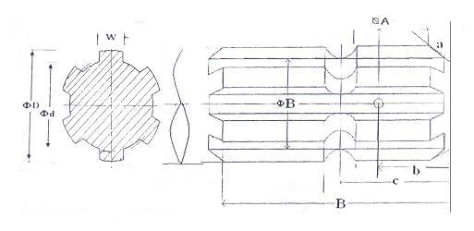
Fig. : Dimension of Implement Power Input Shaft as per IS
 | Propeller shaft:
 | a) | Type | :
 | b) | Length of shaft (mm)
 |  | Minimum | :
 |  | Maximum | :
 | c) | Mass of shaft (kg) | :
 | d) | Provision for locking | :
 | e) | Safety provision | :

Propeller Shaft Insert Dimensions as per IS: 4931-2006

Sr. | Notations  (Refer Fig. 3) | Dimensions as per IS: 4931-2006 | Dimensions
1 | D Ø | 34.93+0.03
2 | d Ø | 29.70+0.1
3 | W | 8.69 (min)
4 | B | 54 (min)
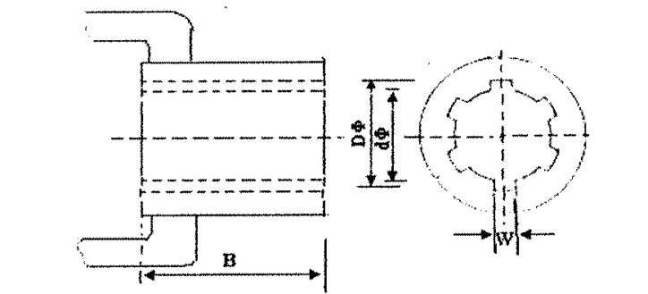
Fig. : Propeller Shaft Insert (Hub) Dimensions as per IS
4.4.8.2 |  | Input shaft to other unit:
 |  | a) | Type of belt |  |  | :
 |  | b) | Provision for tensioning |  |  | :
 |  | c) | Provision for safety guards |  |  | :
Sr. | From |  |  | Size (mm) | To |  |  | Size (mm) | Speed Ratio
1 | PTO pulley (Ø) |  |  |  | Cylinder pulley (Ø)
2 | Cylinder pulley (Ø) |  |  |  | Intermediate pulley (Ø)
3 | Intermediate pulley (Ø) |  |  |  | Intermediate pulley (Ø)
4 | Intermediate pulley (Ø) |  |  |  | Intermediate pulley (Ø)
5 | Intermediate pulley (Ø) |  |  |  | Blower pulley (Ø)
6 | Blower pulley (Ø) |  |  |  | Intermediate pulley (Ø)
7 | Intermediate pulley (Ø) |  |  |  | Eccentric pulley (Ø)

4.4.9 |  | Transporting arrangement:
 |  | a) | Type | :
 |  | b) | Dimensions (mm) | :
 |  | c) | Wheel equipment | :
 |  |  | -Nos. and type of wheels | :
 |  |  | -Make and model | :
 |  |  | -Size | :
 |  |  | -Inflation pressure (kg/cm²) | :
 |  |  | -Nos. and type of bearings | :
 |  | d) | Hitch hook | :
 |  |  | -Size of hook (ID/OD) mm | :
 |  |  | -Height of hook from ground level (mm) | :
4.5 | Details of material of construction :
Material of Construction Data Sheet (Annex B, Clause 6.2, IS:6284-2004)

Sr. | Components | Material
1 | Frame
2 | Feeding system
3 | Threshing unit
4 | Drum
5 | Beater/projection/bar/Spike
6 | Concave
7 | Blower
8 | Main shaft
9 | Blower shaft
10 | Flywheel
11 | Sieve
12 | Shaker
13 | Elevator
14 | Transport wheel
15 | Pulleys
16 | Sliding pan | --
17 | Others | --

4.6 | Lubricating points:
Sr. | Location | Nos. of lubricating points | Recommended lubricant | Lubricating schedule after
1 | Main shaft bearing | 3 cup/ nipples
2 | Shaker shaft bearings | 2 cup/nipples
3 | Hangers | 8 cups/nipples

4.7 | Overall dimensions (with feeding chute and transporting arrangement)(mm):
 | a) | Length | :
 | b) | Width | :
 | c) | Height | :
 | d) | Ground clearance (below axle) | :
 | e) | Total weight (kg) | :
 |  | - With prime mover | :
 |  | - Without prime-mover | :
4.8 | Colour of the machine |  | :

Place:
Date:
Signature : _________________________

Name : _________________________

Designation: ________________________

